UAS EMERGENCY PROCEDURES TEMPLATE

These are a selection of typical emergency procedures, but please tailor them to your UAS and it’s manufacturer recommended operating instructions.
Your UAS may not respond in the way described below or have the features mentioned to recover from an undesirable aircraft state.

A2 CofC COURSE CANDIDATES
The below templates, if tailored to your equipment, can be a handy tool to help work towards the completion of your Self Study practical flight training.

GVC COURSE CANDIDATES
Please remember you must be very familiar with the procedure you choose to use as during your Flight Assessment as you will be assessed against these from memory.
There won’t be time to consult any flight reference cards during the assessment or in a real emergency.

The emergency procedures below MUST be checked against your equipment’s specifications and manufacturers recommendations as amended as needed.

G.1 Pilot Incapacitation
Symptom/Issue | Warning | Pilot Action | Crew Action | Remarks
Pilot incapacitation |  | Activate RTH (Return to Home) or BL (Back Landing) if possible. | Pick up controller.  Confirm launch area clear.  Monitor video display (if still functioning).  Initiate Return to Home procedure OR land the UAS if trained to do so.  Administer First Aid to pilot as appropriate  Call Emergency Services if required | Administer first aid to pilot.  When Return to Home is initiated: If below 20m the UAS will climb to 20m (if already above 20m the UAS will stay at the same height)  The UAS will return directly to the launch position, hover for 15 seconds then gradually descend until it lands, and the motors will automatically disarm.  Report to appropriate bodies as identified in section 3.8

G.2 Airspace Incursion
Symptom/Issue | Warning | Pilot Action | Crew Action | Remarks
Airspace Incursion | Visible or audible signs of another air user in the location. | Climb or descend as appropriate.  Alert crew to issue.  When location of other air user has been identified move directly away, land if safe to do so. | Crew to prioritise the identification of the location of the other air user.  Crew to keep pilot aware of what they can see.  Ensure landing location is clear. | Record any relevant information relating to the airspace incursion for UK AirProx Board.  Report to appropriate bodies as identified in section 3.8

G.3 Ground Incursion
Symptom/Issue | Warning | Pilot Action | Crew Action | Remarks
Ground Incursion | Visible or audible signs of unauthorized person in the location. | Climb and move UAS as appropriate and achieve suitable separation.  Alert crew to issue.  When location of people has been identified move away, land if safe to do so. | Crew priority to identify the location of the person.  Crew to keep pilot aware of what they can see.  Confirm launch/landing area clear | The minimum separation from uninvolved persons will be 50 metres in flight

G.4 Loss of Control Data Link
Symptom/Issue | Warning | Pilot Action | Crew Action | Remarks
Loss of Control Data Link | UAS unresponsive.  Poor signal strength.  UAS shows fast flashing amber lights | Alert crew to issue.  Attempt to regain control of the UAS by changing flight mode from its current mode to an alternate and back. | Ensure landing location is clear.  Monitor video display (if still functioning).  Provide pilot with appropriate updates on status. | UAS will enter a ‘failsafe’ mode in this situation after 3 seconds.  When failsafe is initiated: If below 20m the UAS will climb to 20m (if already above 20m the UAS will stay at the same height)  The UAS will return directly to the launch position, hover for 15 seconds then gradually descend until it lands, and the motors will automatically disarm.  If UAS re-acquires link at any time the pilot can change the flight mode to regain control of the RPA by cycling the flight mode switch.  Pilot must land the RPA as soon as it is safe to do so to investigate the issues.  Report to appropriate bodies as identified in section 3.8

G.5 Rogue UAS
Symptom/Issue | Warning | Pilot Action | Crew Action | Remarks
UAS flying without response from Remote Pilot and uncontrollable | UAS unresponsive. | Alert crew to issue.  Attempt to regain control of the UAS by changing flight mode switch.  Attempt to initiate Return to Home using switch.  Turn off Pilot Controller to attempt to force a failsafe. If this does not work turn controller back on again and try to regain control.  If control regained, bring UAS home and land.  If control not regained, prepare for crash landing.  Call “CLEAR”  Proceed to crash site if possible  Inform local ATC if required  Inform emergency services if required | Identify a landmark on the horizon to assist with identifying direction of flight, from launch area or mark location.  Monitor video display (if still functioning). Provide pilot with appropriate updates on status.  Take a bearing of the direction of flight.  Inform local ATC if required  Inform emergency services if required | Dependent on outcome possibly inform the relevant agencies and personnel.  Report to appropriate bodies as identified in section 3.8

G.6 Loss of Power (UAS)
Symptom/Issue | Warning | Pilot Action | Crew Action | Remarks
Loss of power (UAS) | Un-commanded descent | Alert crew to impending crash.  Attempt to regain control by changing flight mode switch.  If control regained, bring UAS home and land.  If control not regained, prepare for crash landing.  Call “CLEAR”  Proceed to crash site if possible  Inform local ATC if required  Inform emergency services if required | Identify a landmark on the horizon to assist with location of UAS.  Monitor video display (if still functioning).  Provide pilot with appropriate updates on status.  Proceed to crash site if possible  Inform local ATC if required  Inform emergency services if required | Carry out post-crash management procedure.  Report to appropriate bodies as identified in section 3.8

G.7 Loss of Power (Ground Control Equipment)
Symptom/Issue | Warning | Pilot Action | Crew Action | Remarks
Loss of power (ground control equipment) | Tablet screen extinguished.  Green connection light and / or white power lights on RC extinguish.  UAS shows fast flashing amber lights. | Alert crew to the loss of control.  Ensure landing site is cleared.  Watch behaviour of machine to ensure failsafe is operating correctly. If not initiate Rogue UAS procedure. | Monitor video display (if still functioning).  Provide pilot with appropriate updates on status. | If UAS experiences control data loss for more than 3 sec it will enter the failsafe mode.  If UAS experiences control data loss for more than 3 seconds, it will enter a failsafe mode.  When failsafe is initiated: If below 20m the UAS will climb to 20m (if already above 20m the UAS will stay at the same height)  The UAS will return directly to the launch position, hover for 15 seconds then gradually descend until it lands, and the motors will automatically disarm.  If UAS re-acquires link at any time the pilot can change the flight mode to regain control of the UAS.  Pilot must land the UAS as soon as it is safe to do so to investigate the issues.  Report to appropriate bodies as identified in section 3.8

G.8 Unexpected Behaviour in Flight
Symptom/Issue | Warning | Pilot Action | Crew Action | Remarks
Unexpected behaviour in flight |  | Alert crew to the loss of control.  Ensure landing site is cleared.  Pilot must land the UAS as soon as it is safe to do so to investigate the issues. | Monitor video display (if still functioning).  Provide pilot with appropriate updates on status. | Report to appropriate bodies as identified in section 3.8

G.9 Lithium Polymer Battery Fault
Symptom/Issue | Warning | Pilot Action | Crew Action | Remarks
Swelling of battery or overheating  From impact damage following aircraft crash, dropping of battery, or charging malfunction |  | Alert crew to the fault.  Call “CLEAR”  If RPA is in flight and still under control land immediately in a safe area away from public.  Inform emergency services as required.  Cordon off area 30m radius from battery/UAS.  If necessary and safe to do so use extinguisher. | Crew to keep location of fire clear.  Inform emergency services as required.  Cordon off area 30m radius from battery/RPA.  If necessary and safe to do so use extinguisher. | LiPo batteries are highly dangerous and can explode  Keep distance until safe to approach  First on scene of UAS:  approach battery with extreme caution, wearing PPE (goggles, fire resistant gloves), LiPo bag and with fire extinguisher to hand.  Dispose of battery in accordance to safety guidelines OR safely discharge battery.  Report to appropriate bodies

G.10 UAS Fire
Symptom/Issue | Warning | Pilot Action | Crew Action | Remarks
Smoke / fire |  | Alert crew to the fire.  Call “CLEAR”  If RPA is in flight and still under control land immediately in a safe area away from public.  Inform emergency services as required.  Cordon off area 30m radius from battery/RPA/crash site.  If safe to do so use extinguisher. | Crew to keep location of fire / crash site clear.  Inform emergency services as required.  Cordon off area 30m radius from battery/RPA/crash site.  If safe to do so use extinguisher. | LiPo batteries are highly dangerous and can explode  Keep distance until safe to approach  First on scene of RPA:  approach battery with extreme caution, wearing PPE (goggles, fire resistant gloves), LiPo bag and with fire extinguisher to hand.  Dispose of battery in accordance to safety guidelines.  Report to appropriate bodies as identified in section 3.8

G.11 Loss of GNSS signal
[RTH FUNCTIONS WILL NOT WORK IF EXPERIENCING GNSS/COMPASS ISSUES]

Symptom/Issue | Warning | Pilot Action | Crew Action | Remarks
Loss of GPS modes in-flight.  Aircraft fails to hold position lock | Visual warning on iOSD  Aircraft may switch to a non-GPS mode (i.e. ATTI / OPTI)  Aircraft status light may change. | Immediately switch to non-GPS assisted mode.  Land at the nearest suitable TOLZ.  In the event that Pilot is unable to regain control, refer to G.4 Rogue UAS | Clear operational area of all personnel  Identify clear TOLZ  Provide pilot with appropriate updates on status. | Operation should be aborted until GPS can be established.  UNLESS it is safe to continue the flight without the use of GPS and the functionality it provides (e.g. GPS RTH)  Report to appropriate bodies as identified in section 3.8

G.12 Compass Error

[RTH FUNCTIONS WILL NOT WORK IF EXPERIENCING GNSS/COMPASS ISSUES]

Symptom/Issue | Warning | Pilot Action | Crew Action | Remarks
Loss of GPS mode in-flight  Aircraft fails to hold heading | Visual warning on iOSD  Aircraft may switch to a non-GPS assisted mode (i.e. ATTI / OPTI)  Aircraft status light may change  Aircraft may fail to keep commanded heading | Land at the nearest suitable TOLZ  Consider Switching to ATTI Mode if available  If aircraft begins to yaw uncontrollably, consider landing underneath flight path provided safe to do so  In the event that pilot is unable to regain control, refer to G.4 Rogue UAS | Clear operational area of all personnel  Identify clear TOLZ and/or clear area below flight path  Provide pilot with updates on status | Operation should be aborted until Compass error is rectified.  Refer to pre-flight documents to reassess any electromagnetic interference or distortion risks.  Report to appropriate bodies as identified in section 3.8  Consider servicing aircraft for further investigation

G.13 Abnormal Environmental Conditions
Symptom/Issue | Warning | Pilot Action | Crew Action | Remarks
Abnormal  environmental  conditions and C2 link loss/Loss of control of the aircraft | UAS losing control in mid-air due to bad weather (high winds / precipitation)  Magnetic interference (fly with caution) warning | Alert crew to issue  Attempt to land if RP still has relative control of the aircraft  If pilot loses complete control, thus resulting in the UAS falling to the ground, shout "CLEAR" to ensure people exit the area of potential incursion  Check KP index before operation and calibrate compass before operation if needed. | Ensure landing location is clear  If UAS is falling out of the air, also shout "CLEAR" to alert anyone nearby. | Before the pilot loses complete control, they should have noticed the UAS becoming less stable, and attempt to land the UAS at their primary launch site, or secondary if this is not  available.  If this is not available, they and the crew must shout "CLEAR" if the UAS starts to fall to the ground after loss of  control.

IF A EMEREGENCY HAS OCCURRED, WHAT ARE THE REQUIRED FOLLOW UP ACTIONS?

OPEN CATEGORY OCCURRENCE REPORTING FLOWCHART | SPECIFIC CATEGORY OCCURRENCE REPORTING FLOWCHART
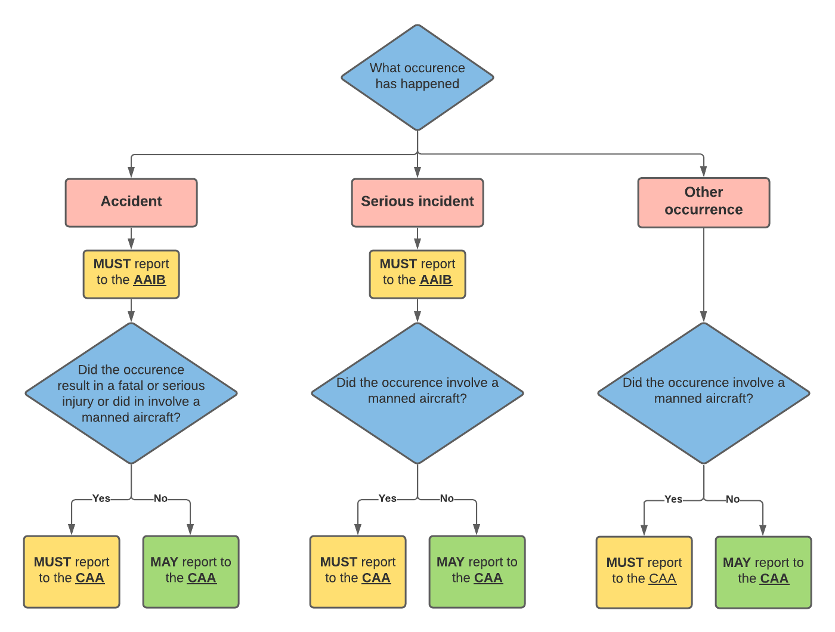 | 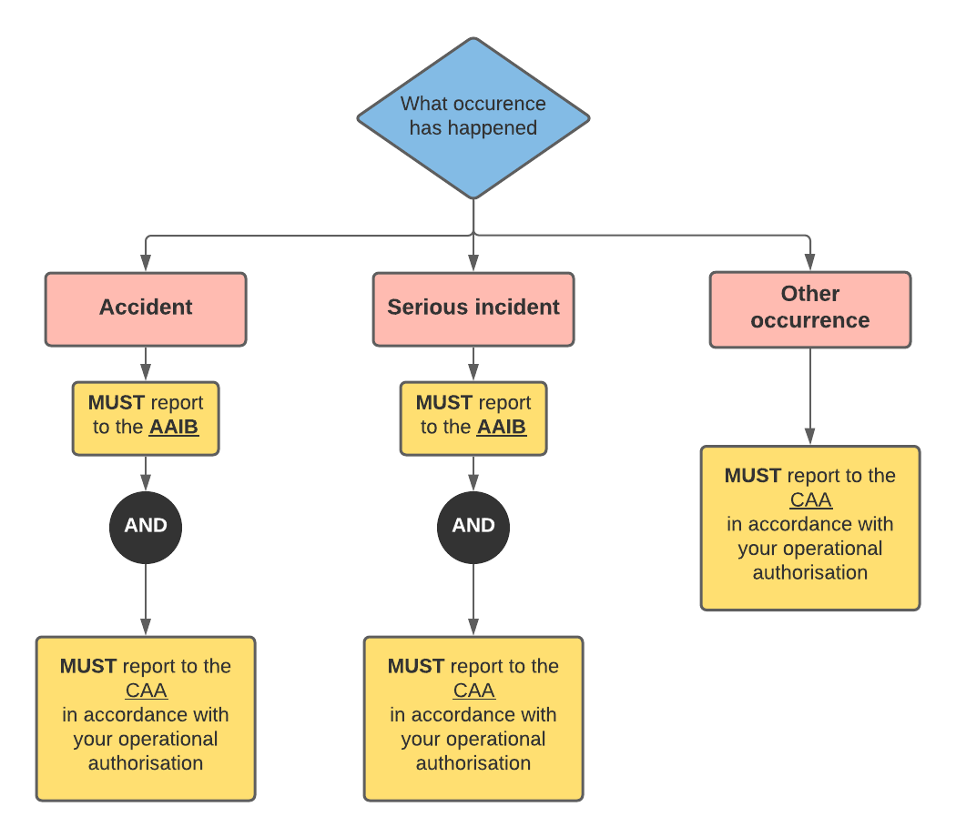
Additional information and guidance on reporting can be found in CAP722 - Unmanned Aircraft System Operations in UK Airspace – Guidance
2.9.6.1. Open category occurrence reporting flowchart
2.9.6.2. Specific category occurrence reporting flowchart
CAP 722: Unmanned Aircraft System Operations in UK Airspace - Guidance

https://www.aviationreporting.eu/AviationReporting/
https://www.airproxboard.org.uk/home/
https://www.gov.uk/government/organisations/air-accidents-investigation-branch

