INCIDENT LOGBOOK
DATE | TIME | INJURIES / DAMAGE | INCIDENT DETAILS | ACTION TAKEN / INCIDENT REPORT | NOTES | MORS REPORT SUBMITTED?
*MORS – Mandatory Occurrence Reporting Scheme

OCCURRENCE REPORTING REQUIREMENTS
OPEN CATEGORY OCCURRENCE REPORTING FLOWCHART | SPECIFIC CATEGORY OCCURRENCE REPORTING FLOWCHART
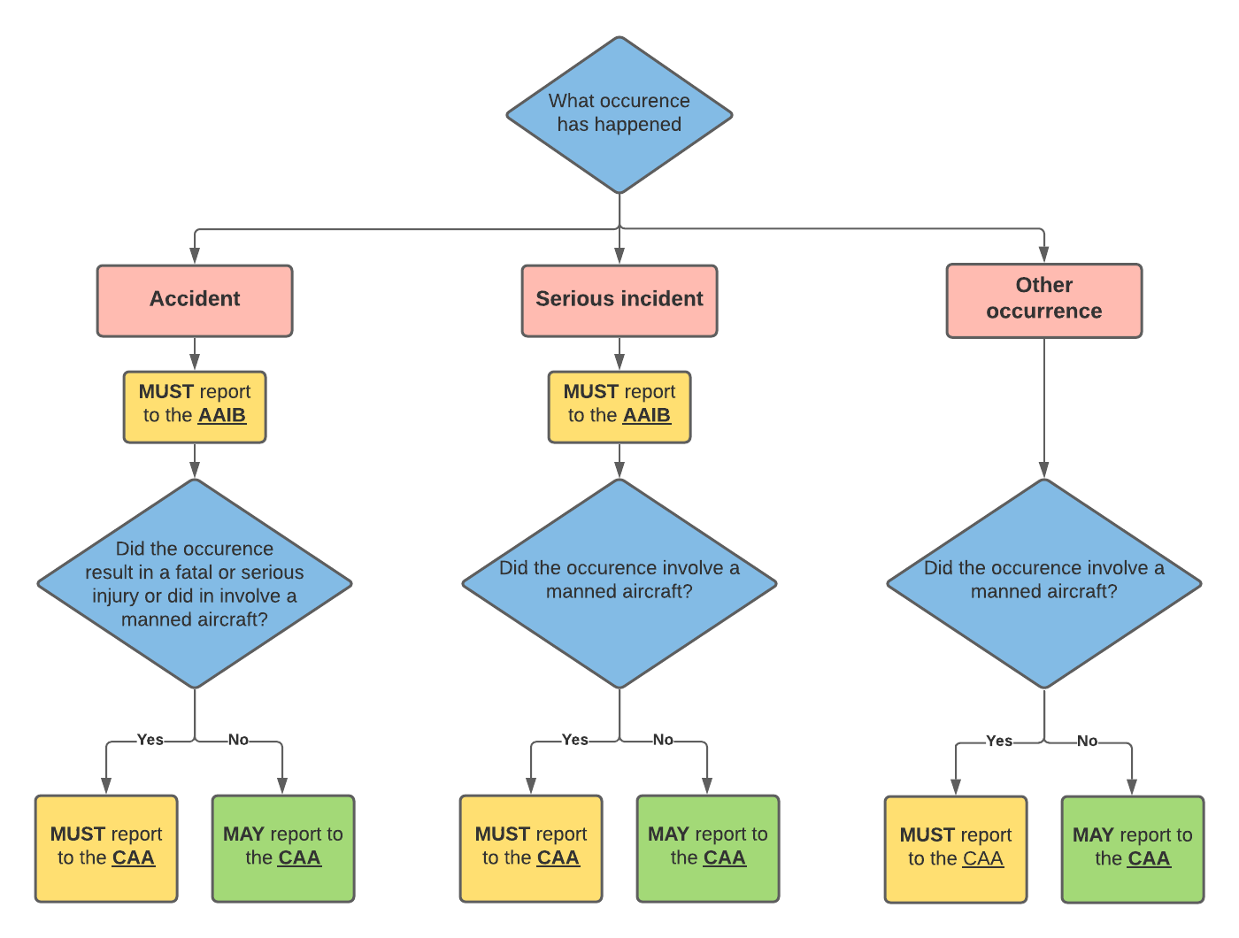 | 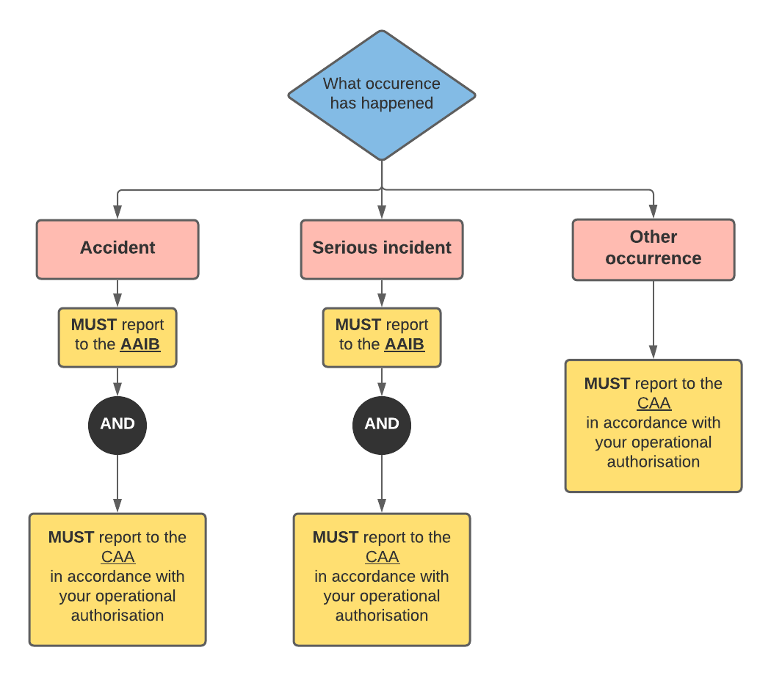
Additional information and guidance on reporting can be found in CAP722 - Unmanned Aircraft System Operations in UK Airspace – Guidance
2.9.6.1. Open category occurrence reporting flowchart
2.9.6.2. Specific category occurrence reporting flowchart

